| **Test Name** | | Add error to system | | | |
| --- | --- | --- | --- | --- | --- |
| **Use Case Tested:** | | Use Case 1 – Add Error to System – Physician Not Advised | | | |
| **Test Description:** | | User:   * Enters the date the error occurred * Enters the time the error occurred * Enters the patient MRN (hospital ID for patient) * Enters the patient’s first name * Enters the patient’s surname * Selects the patient type * Selects the error type * Enters name of medication * Selects medication type * Enters a description/comment * Selects the person who made the error * Selects if person making error has been notified * Selects where error was detected * Selects if IIMS was completed * Selects the severity level * Selects if physician was notified (No) * Selects Submit button | | | |
| **Pre-conditions** | | User has successfully logged in.  Enter an Error page is presented to user | | | |
| **Post-conditions** | | When Physician Advised field is selected as NO, following fields are not enabled for data input  Database is successfully updated with the data on selection of Submit button | | | |
| **Notes:** | |  | | | |
| **Result (Pass/Fail/Warning/Incomplete)** | |  | | | |
|  | **TEST STEP** | | **EXPECTED TEST RESULTS** | P | F |
|  | Date is selected | | Date is accepted | P |  |
|  | Time is selected | | Time is accepted | P |  |
|  | Patient MRN is entered | | Patient MRN is not found in database and is accepted | P |  |
|  | Patient first name is entered | | Patient first name is accepted | P |  |
|  | Patient surname is entered | | Patient surname is accepted | P |  |
|  | Patient type is selected | | Selection accepted | P |  |
|  | Error type is selected | | Selection accepted | P |  |
|  | Medication Given entered | | Medication is accepted | P |  |
|  | Medication type is selected | | Selection accepted | P |  |
|  | Error description/comment is entered | | Error description/comment is accepted | P |  |
|  | Person making error is selected | | Selection accepted | P |  |
|  | Person making error notified selected | | Selection accepted | P |  |
|  | Where error detected selected | | Selection accepted | P |  |
|  | IIMS completed selected | | Selection accepted | P |  |
|  | Severity level is selected | | Selection accepted | P |  |
|  | Physician notified – No is selected | | Selection accepted and following fields are not enabled | P |  |
|  | Physician provider number is disabled | | Unable to enter data | P |  |
|  | Physician first name is disabled | | Unable to enter data | P |  |
|  | Physician surname is disabled | | Unable to enter data | P |  |
|  | Physician comments is disabled | | Unable to enter data | P |  |
|  | Patient diagnosis is disabled | | Unable to enter data | P |  |
|  | User selects Submit button | | Database updated with data as entered above |  | F |

NOTE: Only some tables updated with data. Error form did not clear.

|  |  |  |  |  |  |
| --- | --- | --- | --- | --- | --- |
| **Test Data Table** | | | | | |
|  | **1** | **2** | **3** | **4** | **5** |
| Date: | 2018-05-15 |  |  |  |  |
| Time: | 23:19 |  |  |  |  |
| Patient MRN: | Hdoo987 |  |  |  |  |
| Patient First Name | Braeden |  |  |  |  |
| Patient Surname | Gardiner |  |  |  |  |
| Patient Type: | Outpatient |  |  |  |  |
| Error Type: | Dosage / Strength |  |  |  |  |
| Medication: | Panadeine Forte |  |  |  |  |
| Medication Type: | Oral |  |  |  |  |
| Error Description/Comment: |  |  |  |  |  |
| Person Making Error | Timothy Meyers |  |  |  |  |
| Person Making Error Notified: | Yes |  |  |  |  |
| Where Error was Detected: | Outside hospital |  |  |  |  |
| IIMS Completed: | Yes |  |  |  |  |
| Severity Level | Moderate-low |  |  |  |  |
| Physician Notified: | No |  |  |  |  |
| Physician Provider Number: |  |  |  |  |  |
| Physician First Name: |  |  |  |  |  |
| Physician Surname: |  |  |  |  |  |
| Physician comments: |  |  |  |  |  |
| Patient Diagnosis: |  |  |  |  |  |

SCREENSHOTS OF TEST

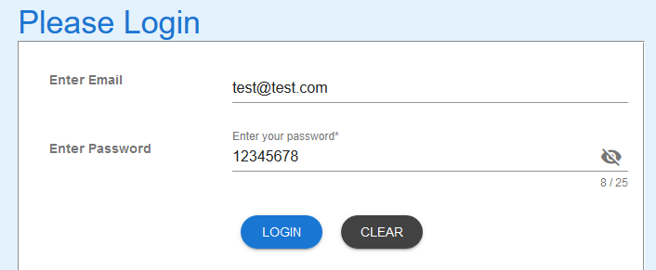

Successful user login

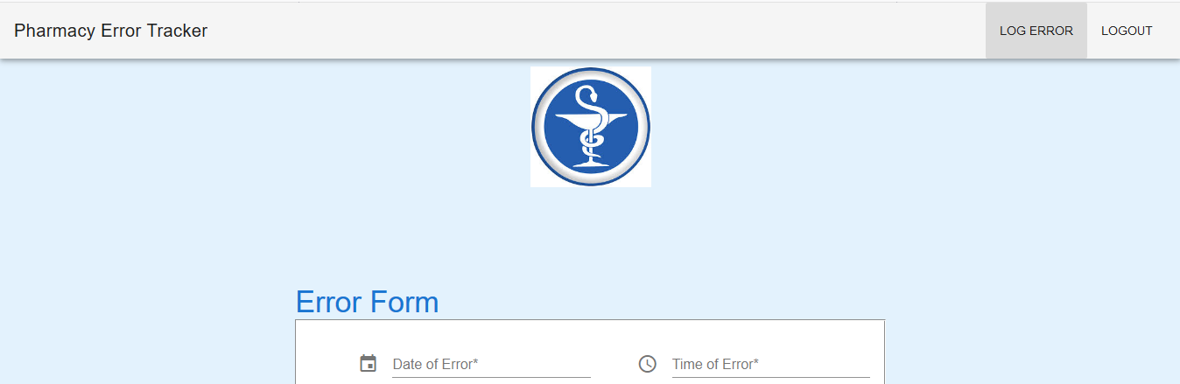

Error page presented to user

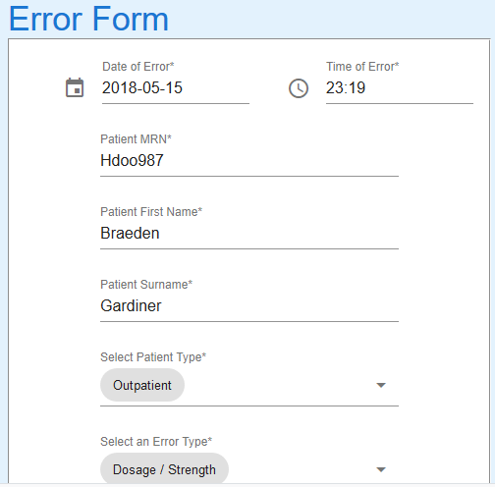

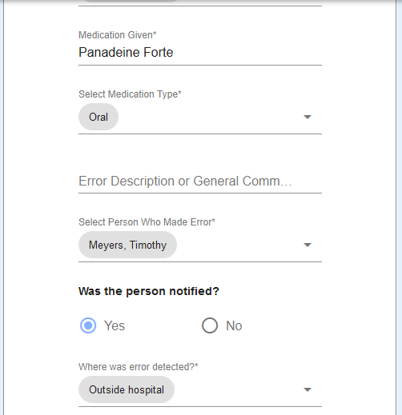

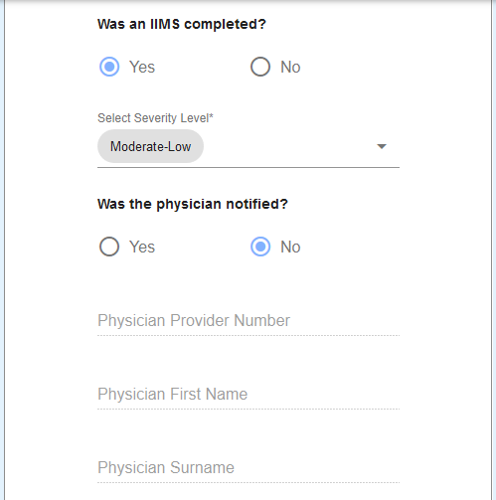

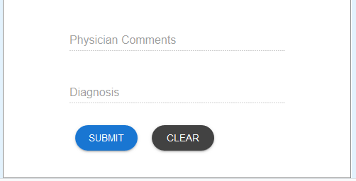

Data entered into fields as per test data. No errors in fields. Physician fields are disabled and can’t be selected

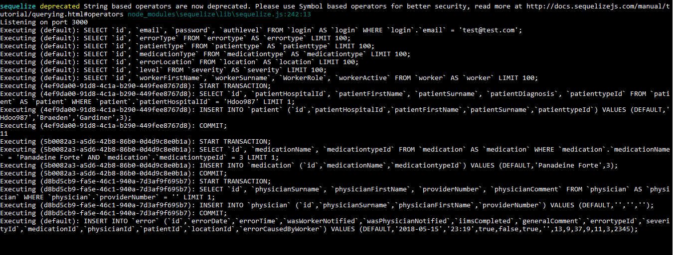

Queries executed on Server

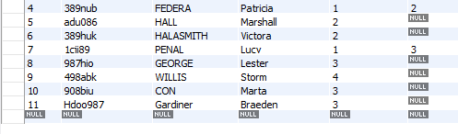

Patient table updated

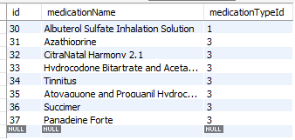

Medication table updated

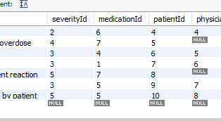

Error table does not show patientId 11